LIBRARY MANAGEMENT SYSTEM (MYSQL)

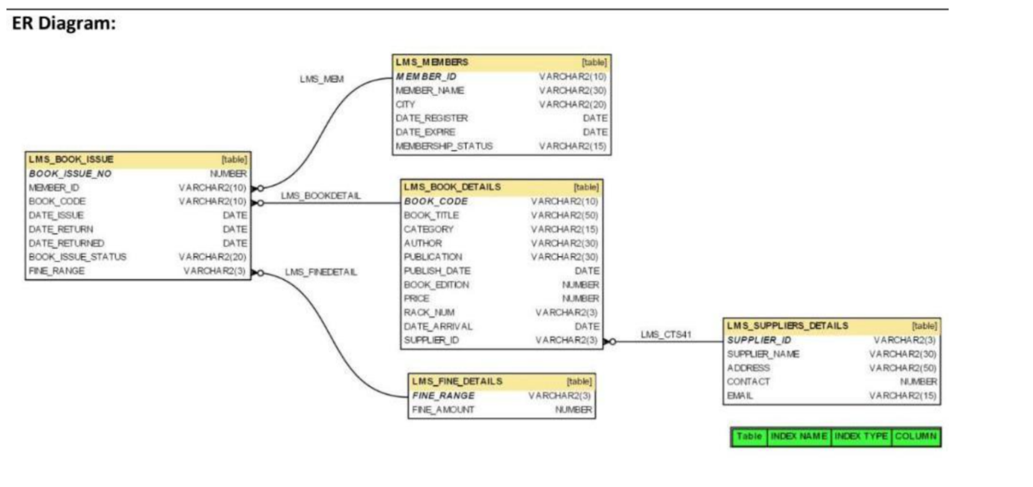

CREATE DATABASE
1.LMS_MEMBERS
CREATE TABLE LMS_MEMBERS (
MEMBER_ID VARCHAR(10) PRIMARY KEY,
MEMBER_NAME VARCHAR(30),
CITY VARCHAR(20),
DATE_REGISTER DATE,
DATE_EXPIRE DATE,
MEMBERSHIP_STATUS VARCHAR(15)
);

2.LMS_SUPPLIER DETAILS
CREATE TABLE LMS_SUPPLIERS_DETAILS (
SUPPLIER_ID VARCHAR(3) PRIMARY KEY,
SUPPLIER_NAME VARCHAR(30),
ADDRESS VARCHAR(50),
CONTACT BIGINT,
EMAIL VARCHAR(15)
);

3.LMS_FINE DETAILS
CREATE TABLE LMS_FINE_DETAILS (
FINE_RANGE VARCHAR(3) PRIMARY KEY,
FINE_AMOUNT DECIMAL(10,2)
);

4.LMS_BOOK_DETAILS
CREATE TABLE LMS_BOOK_DETAILS (
BOOK_CODE VARCHAR(10) PRIMARY KEY,
BOOK_TITLE VARCHAR(50),
CATEGORY VARCHAR(15),
AUTHOR VARCHAR(30),
PUBLICATION VARCHAR(30),
PUBLISH_DATE DATE,
BOOK_EDITION INT,
PRICE DECIMAL(10,2),
RACK_NUM VARCHAR(3),
DATE_ARRIVAL DATE,
SUPPLIER_ID VARCHAR(3),
FOREIGN KEY (SUPPLIER_ID)
REFERENCES LMS_SUPPLIERS_DETAILS(SUPPLIER_ID)
);

5.LMS_BOOK_ISSUE
CREATE TABLE LMS_BOOK_ISSUE (
BOOK_ISSUE_NO INT PRIMARY KEY,
MEMBER_ID VARCHAR(10),
BOOK_CODE VARCHAR(10),
DATE_ISSUE DATE,
DATE_RETURN DATE,
DATE_RETURNED DATE,
BOOK_ISSUE_STATUS VARCHAR(20),
FINE_RANGE VARCHAR(3),
FOREIGN KEY (MEMBER_ID)
REFERENCES LMS_MEMBERS(MEMBER_ID),
FOREIGN KEY (BOOK_CODE)
REFERENCES LMS_BOOK_DETAILS(BOOK_CODE),
FOREIGN KEY (FINE_RANGE)
REFERENCES LMS_FINE_DETAILS(FINE_RANGE)
);

SHOW TABLES;
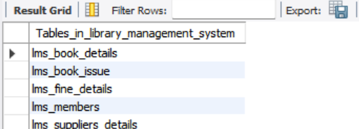

DATA INSERTION IN TABLES
SUPPLIER DATA:
INSERT INTO LMS_SUPPLIERS_DETAILS
(SUPPLIER_ID, SUPPLIER_NAME, ADDRESS, CONTACT, EMAIL)
VALUES
('S01','Prentice Hall','Hyderabad',9876500001,'s01@gmail.com'),
('S02','Pearson','Chennai',9876500002,'s02@gmail.com'),
('S03','McGraw Hill','Delhi',9876500003,'s03@gmail.com'),
('S04','Oxford Press','Mumbai',9876500004,'s04@gmail.com'),
('S05','Wiley','Bangalore',9876500005,'s05@gmail.com'),
('S06','Springer','Pune',9876500006,'s06@gmail.com'),
('S07','Cengage','Kolkata',9876500007,'s07@gmail.com'),
('S08','OReilly','Hyderabad',9876500008,'s08@gmail.com'),
('S09','Sage','Chennai',9876500009,'s09@gmail.com'),
('S10','Cambridge','Delhi',9876500010,'s10@gmail.com'),
('S11','Pearson India','Mumbai',9876500011,'s11@gmail.com'),
('S12','Tech Press','Bangalore',9876500012,'s12@gmail.com'),
('S13','Data Books','Pune',9876500013,'s13@gmail.com'),
('S14','Global Books','Kolkata',9876500014,'s14@gmail.com'),
('S15','Knowledge House','Hyderabad',9876500015,'s15@gmail.com'),
('S16','Academic Press','Chennai',9876500016,'s16@gmail.com'),
('S17','Elite Publishers','Delhi',9876500017,'s17@gmail.com'),
('S18','Modern Books','Mumbai',9876500018,'s18@gmail.com'),
('S19','Future Books','Bangalore',9876500019,'s19@gmail.com'),
('S20','Scholars Press','Pune',9876500020,'s20@gmail.com');

FINE DETAILS:
INSERT INTO LMS_FINE_DETAILS
(FINE_RANGE, FINE_AMOUNT)
VALUES
('F01',10),
('F02',20),
('F03',30),
('F04',40),
('F05',50),
('F06',60),
('F07',70),
('F08',80),
('F09',90),
('F10',100),
('F11',110),
('F12',120),
('F13',130),
('F14',140),
('F15',150),
('F16',160),
('F17',170),
('F18',180),
('F19',190),
('F20',200);

MEMBERS DETAILS:
INSERT INTO LMS_MEMBERS
(MEMBER_ID, MEMBER_NAME, CITY, DATE_REGISTER, DATE_EXPIRE, MEMBERSHIP_STATUS)
VALUES
('M001','Rahul','Guntur','2012-01-10','2014-01-10','Permanent'),
('M002','Priya','Hyderabad','2012-02-15','2013-02-15','Temporary'),
('M003','Arun','Vijayawada','2011-12-20','2014-12-20','Permanent'),
('M004','Sneha','Chennai','2012-01-05','2013-01-05','Temporary'),
('M005','Kiran','Delhi','2012-04-10','2015-04-10','Permanent'),
('M006','Anu','Mumbai','2011-11-12','2013-11-12','Permanent'),
('M007','Ravi','Bangalore','2012-02-20','2013-02-20','Temporary'),
('M008','Meena','Pune','2012-05-15','2015-05-15','Permanent'),
('M009','Vijay','Kolkata','2011-10-10','2013-10-10','Permanent'),
('M010','Pooja','Hyderabad','2012-01-25','2013-01-25','Temporary'),
('M011','Suresh','Guntur','2012-06-10','2015-06-10','Permanent'),
('M012','Divya','Chennai','2012-07-12','2015-07-12','Permanent'),
('M013','Ajay','Delhi','2011-09-15','2013-09-15','Permanent'),
('M014','Lakshmi','Mumbai','2012-02-01','2013-02-01','Temporary'),
('M015','Manoj','Bangalore','2012-08-20','2015-08-20','Permanent'),
('M016','Swathi','Pune','2011-08-10','2013-08-10','Permanent'),
('M017','Naveen','Kolkata','2012-03-15','2015-03-15','Permanent'),
('M018','Asha','Hyderabad','2012-01-20','2013-01-20','Temporary'),
('M019','Ramesh','Guntur','2012-09-10','2015-09-10','Permanent'),
('M020','Deepa','Chennai','2011-07-25','2013-07-25','Permanent');

BOOK DETAILS:
INSERT INTO LMS_BOOK_DETAILS
(BOOK_CODE, BOOK_TITLE, CATEGORY, AUTHOR, PUBLICATION, PUBLISH_DATE, BOOK_EDITION, PRICE, RACK_NUM, DATE_ARRIVAL, SUPPLIER_ID)
VALUES
('BL000001','Java Programming','Java','James Gosling','Prentice Hall','2010-01-10',1,500,'R01','2011-01-10','S01'),
('BL000002','Python Basics','Programming','Paul Barry','Pearson','2011-02-15',2,450,'R02','2011-03-10','S02'),
('BL000003','Advanced Java','Java','Patrick Naughton','Prentice Hall','2010-05-20',2,600,'R03','2011-05-20','S01'),
('BL000004','C Programming','Programming','Dennis Ritchie','McGraw Hill','2009-03-10',3,400,'R04','2010-04-10','S03'),
('BL000005','Database Systems','Database','Abraham Silberschatz','Prentice Hall','2011-04-12',5,700,'R05','2011-06-15','S01'),
('BL000006','Java Fundamentals','Java','Herbert Schildt','McGraw Hill','2012-01-10',4,550,'R06','2012-02-10','S03'),
('BL000007','Web Development','Web','Paul Deitel','Pearson','2011-05-15',2,650,'R07','2011-07-10','S02'),
('BL000008','Python Advanced','Python','Mark Lutz','OReilly','2012-02-20',3,750,'R08','2012-03-10','S08'),
('BL000009','Operating Systems','OS','Abraham Silberschatz','Wiley','2010-06-15',8,800,'R09','2011-01-15','S05'),
('BL000010','Computer Networks','Networking','Andrew Tanenbaum','Pearson','2011-08-10',5,850,'R10','2012-01-10','S02'),
('BL000011','Java Complete Reference','Java','Herbert Schildt','Prentice Hall','2012-03-10',9,900,'R11','2012-04-10','S01'),
('BL000012','Machine Learning','AI','Peter Harrington','OReilly','2013-01-10',1,950,'R12','2013-02-10','S08'),
('BL000013','Data Structures','Programming','Pankaj Sharma','Prentice Hall','2011-09-10',2,500,'R13','2012-01-20','S01'),
('BL000014','Algorithms','Programming','Robert Sedgewick','Pearson','2010-10-10',4,780,'R14','2011-02-20','S02'),
('BL000015','Software Engineering','SE','Roger Pressman','McGraw Hill','2012-05-10',7,850,'R15','2012-06-10','S03'),
('BL000016','Cloud Computing','Cloud','Thomas Erl','Pearson','2013-02-10',2,700,'R16','2013-03-10','S02'),
('BL000017','Artificial Intelligence','AI','Patrick Winston','Prentice Hall','2011-11-10',3,900,'R17','2012-01-10','S01'),
('BL000018','Computer Graphics','Graphics','Donald Hearn','Pearson','2010-12-10',6,820,'R18','2011-04-10','S02'),
('BL000019','Java Enterprise','Java','Paul Deitel','Prentice Hall','2012-02-10',2,880,'R19','2012-04-01','S01'),
('BL000020','Digital Logic','Electronics','Morris Mano','Pearson','2011-03-10',4,600,'R20','2011-05-10','S02');

BOOK ISSUE DETAILS:
INSERT INTO LMS_BOOK_ISSUE
(BOOK_ISSUE_NO, MEMBER_ID, BOOK_CODE, DATE_ISSUE, DATE_RETURN, DATE_RETURNED, BOOK_ISSUE_STATUS, FINE_RANGE)
VALUES
(1,'M001','BL000001','2012-03-01','2012-03-15','2012-03-14','Y','F01'),
(2,'M002','BL000002','2012-03-05','2012-03-20',NULL,'N','F02'),
(3,'M003','BL000003','2012-03-10','2012-03-25','2012-03-24','Y','F03'),
(4,'M004','BL000004','2012-03-12','2012-03-27',NULL,'N','F04'),
(5,'M005','BL000005','2012-04-01','2012-04-15','2012-04-14','Y','F05'),
(6,'M006','BL000006','2012-04-01','2012-04-15',NULL,'N','F06'),
(7,'M007','BL000007','2012-04-01','2012-04-20','2012-04-19','Y','F07'),
(8,'M008','BL000008','2012-04-02','2012-04-17',NULL,'N','F08'),
(9,'M009','BL000009','2012-04-03','2012-04-18','2012-04-17','Y','F09'),
(10,'M010','BL000010','2012-04-04','2012-04-19',NULL,'N','F10'),
(11,'M011','BL000011','2012-04-05','2012-04-20','2012-04-19','Y','F11'),
(12,'M012','BL000012','2012-04-06','2012-04-21',NULL,'N','F12'),
(13,'M013','BL000013','2012-04-07','2012-04-22','2012-04-21','Y','F13'),
(14,'M014','BL000014','2012-04-08','2012-04-23',NULL,'N','F14'),
(15,'M015','BL000015','2012-04-09','2012-04-24','2012-04-23','Y','F15'),
(16,'M016','BL000016','2012-04-10','2012-04-25',NULL,'N','F16'),
(17,'M017','BL000017','2012-04-11','2012-04-26','2012-04-25','Y','F17'),
(18,'M018','BL000018','2012-04-12','2012-04-27',NULL,'N','F18'),
(19,'M019','BL000019','2012-04-13','2012-04-28','2012-04-27','Y','F19'),
(20,'M020','BL000020','2012-04-14','2012-04-29',NULL,'N','F20');

BASIC SQL QUERIES
SELECT * FROM LMS_MEMBERS;
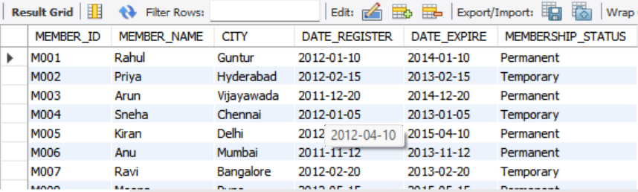

SELECT * FROM LMS_BOOK_DETAILS;
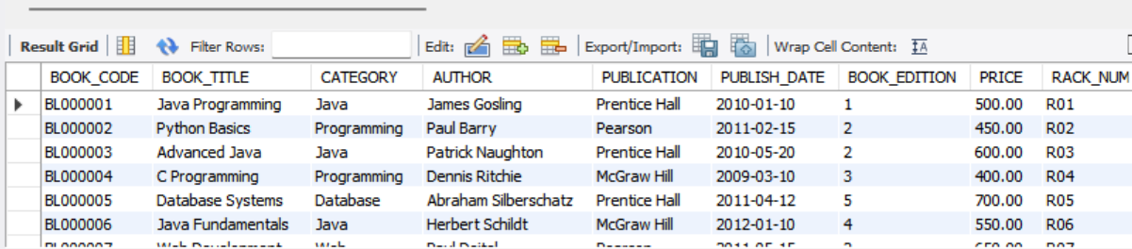

SELECT * FROM LMS_BOOK_ISSUE;
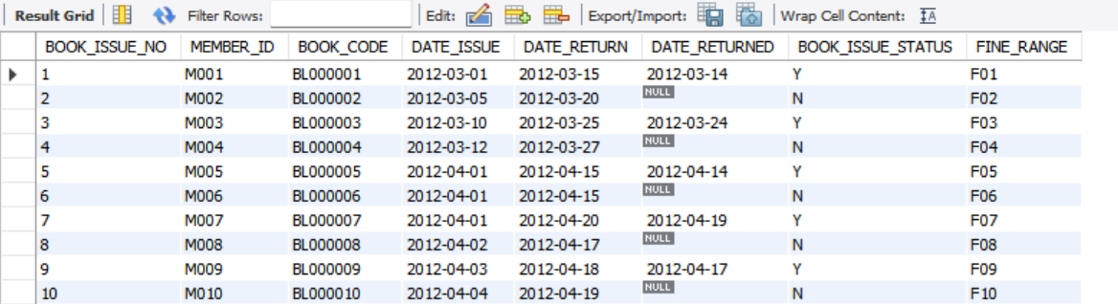

SELECT * FROM LMS_FINE_DETAILS;
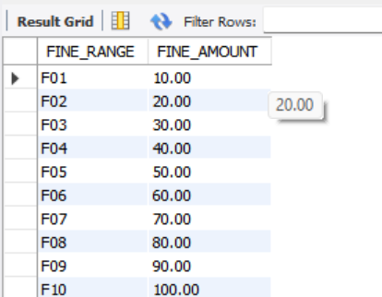

SELECT * FROM LMS_SUPPLIERS_DETAILS;
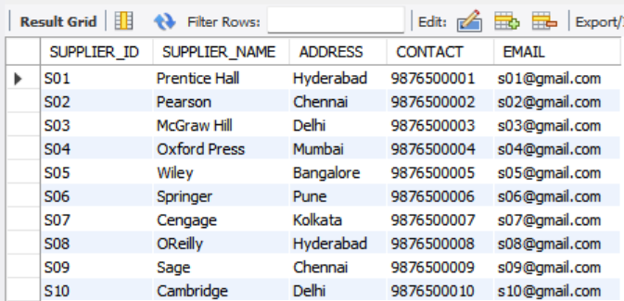

PROJECT QUERIES EXECUTION
1. Write a query to display the member id, member name, city and membership status who are all having life time membership. Hint: Life time membership status is “Permanent”.
QUERY:
SELECT MEMBER_ID,MEMBER_NAME,CITY,MEMBERSHIP_STATUS
FROM LMS_MEMBERS
WHERE MEMBERSHIP_STATUS = 'Permanent';
OUTPUT:
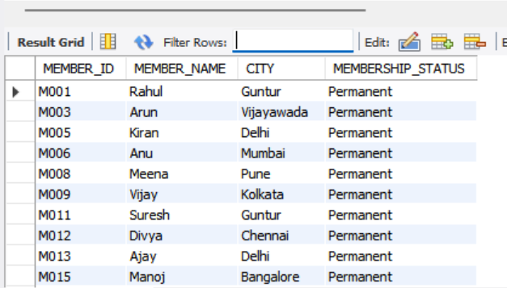

2. Write a query to display the member id, member name who have not returned the books. Hint: Book return status is book_issue_status =’Y’ or ‘N’.
QUERY:
SELECT M.MEMBER_ID,M.MEMBER_NAME
FROM LMS_MEMBERS M
JOIN LMS_BOOK_ISSUE B
ON M.MEMBER_ID = B.MEMBER_ID
WHERE B.BOOK_ISSUE_STATUS = 'N';

OUTPUT:
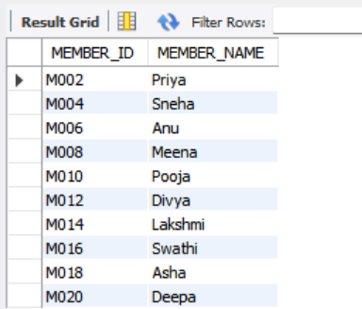

3. Write a query to display the member id, member name who have taken the book with book code ‘BL000002’.
QUERY:
SELECT M.MEMBER_ID,M.MEMBER_NAME
FROM LMS_MEMBERS M
JOIN LMS_BOOK_ISSUE B
ON M.MEMBER_ID = B.MEMBER_ID
WHERE B.BOOK_CODE = 'BL000002';
OUTPUT:
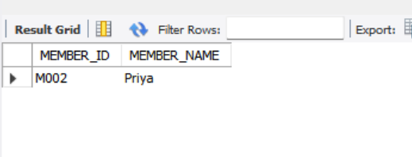

4. Write a query to display the book code, book title and author of the books whose author name begins with ‘P’.

QUERY:
SELECT BOOK_CODE,BOOK_TITLE,AUTHOR
FROM LMS_BOOK_DETAILS
WHERE AUTHOR LIKE 'P%';
OUTPUT:
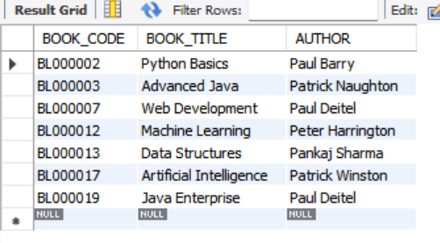

5. Write a query to display the total number of Java books available in library with alias name ‘NO_OF_BOOKS’.
QUERY:
SELECT COUNT(*) AS NO_OF_BOOKS
FROM LMS_BOOK_DETAILS
WHERE CATEGORY = 'Java';
OUTPUT:
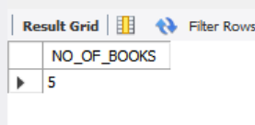

6. Write a query to list the category and number of books in each category with alias name ‘NO_OF_BOOKS’.

QUERY:
SELECT CATEGORY, COUNT(*) AS NO_OF_BOOKS
FROM LMS_BOOK_DETAILS
GROUP BY CATEGORY;
OUTPUT:
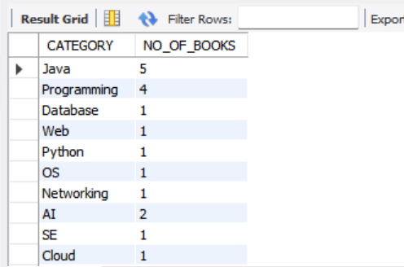

7. Write a query to display the number of books published by "Prentice Hall” with the alias name “NO_OF_BOOKS”.
QUERY:
SELECT COUNT(*) AS NO_OF_BOOKS
FROM LMS_BOOK_DETAILS
WHERE PUBLICATION = 'Prentice Hall';
OUTPUT:
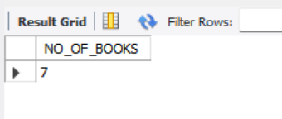

8. Write a query to display the book code, book title of the books which are issued on the date “1st April 2012”.

QUERY:
SELECT B.BOOK_CODE,B.BOOK_TITLE
FROM LMS_BOOK_DETAILS B
JOIN LMS_BOOK_ISSUE I
ON B.BOOK_CODE = I.BOOK_CODE
WHERE I.DATE_ISSUE = '2012-04-01';
OUTPUT:
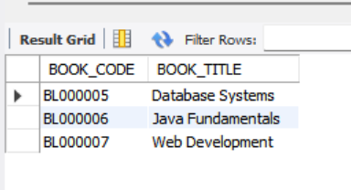

9. Write a query to display the member id, member name, date of registration, membership status of the members who registered before "March 2012" and membership status is "Temporary"
QUERY:
SELECT MEMBER_ID,MEMBER_NAME,DATE_REGISTER,MEMBERSHIP_STATUS
FROM LMS_MEMBERS
WHERE DATE_REGISTER < '2012-03-01'
AND MEMBERSHIP_STATUS = 'Temporary';
OUTPUT:
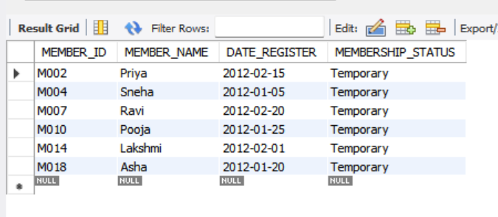
10. Write a query to display the member id, member name, date of registration and expiry date of the members whose membership expiry date is before APR 2013.
QUERY:
SELECT MEMBER_ID,MEMBER_NAME,DATE_REGISTER,DATE_EXPIRE
FROM LMS_MEMBERS
WHERE DATE_EXPIRE < '2013-04-01';
OUTPUT:
